Try Hack Me had a lot of fun and difficult challenges but surprisingly this one tripped-up quite a few people. Here is the write-up for this challenge.

1. Join the TCM Discord

2. Look at the description of the channel inside #ctf-discord-challenge. It will be located at the top of the application.

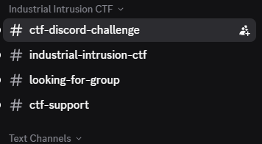 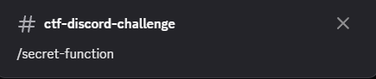

3. Input /secret-function in the chat to initiate the command

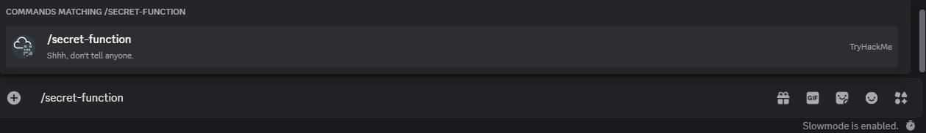

4. The flag will now appear :)



Conclusion: Now that you have your flag, have fun spamming the chat with /table-flip and playing Pong with the TryHackMe bot!